CS 340 README

**About the Project/Project Title**

The is a python program that interacts with the mongodb shell to provide the user with basic crud operations. The basic functions are Create, Read, Update, and Delete with single use methods and multi-use methods.

**Motivation**

This project exists to provide easier access to the basic operations in mongo. This program will increase productivity and modularity by allowing the user to shortcut many of the basic commands. This program will also allow you to write python code to use this program in correlation with your own projects.

**Getting Started**

This program has a very simple setup, you simply download the script. You then need to import the script at the top of your python program. Once this is complete, you now have to create an instance of the object which will start a connection to the database. To do this you can use the following command:



**Installation**

The tools needed for installation are the shell prompt and the latest version of python which can be found at: <https://www.python.org/downloads/> . In addition you will need to import the script to your project by either absolute import or relative import. See <https://realpython.com/absolute-vs-relative-python-imports/> for more information.

**Usage**

Before using the code the mongo db must be imported and the admin account must be setup. Type the commands used in the screen shots below to begin using the commands Using the code is simple, you use a method call and provide it with either data or a query to search for create and read respectively. The method “formatQuery” can also be used with the parameters (ID and Value)

**Database Setup Screen Shots:**



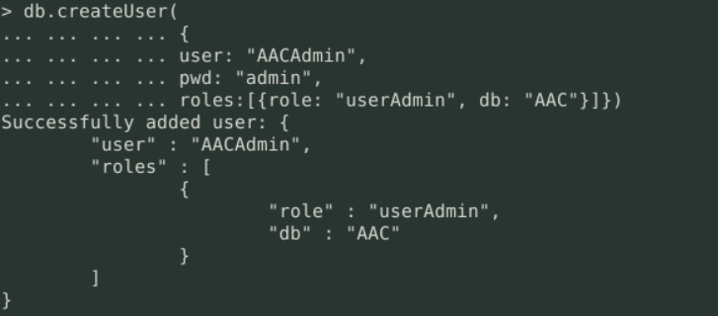

**NOTE: Make sure the role value is set to root for the pymongo authentication to work.

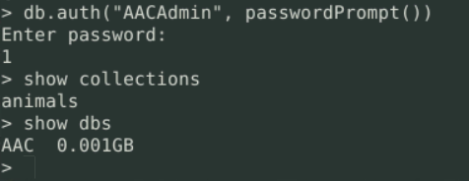

**Code Examples**



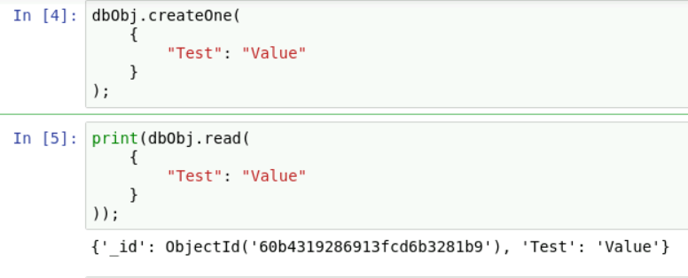

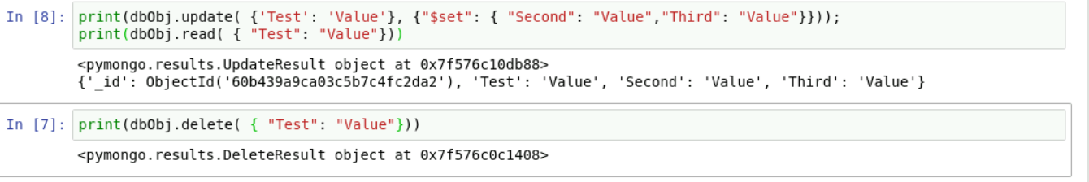

**Contact**

Brian Duncan

Brian.duncan2@snhu.edu